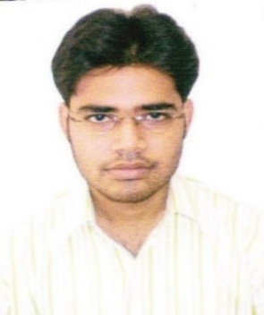

Sarit Chakraborty

Correspondence Address:
85 B Harish Chatterjee Street
Kolkata-700025

Mobile No.- +91-9474714974/7998012415
E-mail id.- saritsoham@gmail.com

Career Objective:

Intend to build a career with leading corporate of hi-tech environment with committed & dedicated people, which will help me to explore myself fully and realize my potential.

Educational Qualification:
Degree | Discipline/  Specialization | School/College | Board/  University | Year of  Passing | Marks
M.B.A. | Marketing | Institute Of Business Management And Research | W.B.U.T. | 2013 | 6.88
Graduation (BBA)(H) | N/A | Dinabandhu Andrews Institute Of Technology And Management | W.B.U.T. | 2011 | 6.11
Higher Secondary (12th) | Bio Science | Mahishadal Raj High School | W.B.C.H.S.E | 2007 | 54.5%
Secondary (10th) | N/A | Mahishadal Raj High School | W.B.B.S.E. | 2005 | 55.1%

Other Courses:

Name of the organization | Duration | Course / Focused on
National Council For Vocational Training | 132 Hours  (Six months) | Computer Fundamentals, MS Office, Internet And Soft Skills

Internship / Training:

Name of the organization | Duration | Project
JOHN PLAYERS | 2 Months | Customer Loyalty And Satisfaction

Projects:

- Project Title - Customer Loyalty And Satisfaction
Organization – ITC JOHN PLAYERS
Duration - 2 Months (15th June, 2012 to 28th August, 2012)

PROFESSIONAL EXPERIENCE

- Designation : MARKETING EXECUTIVE
Company : CALCUTTAYELLOWPAGES.COM (P) Ltd.
Duration : 8 Months (March 2014-Novembr 2014)
- Designation : MARKETING EXECUTIVE
Company : BHARATMATRIMONY.COM LTD
Duration : 2 years (November 2014-August 2016)

Technical Skills / Computer Proficiency:

✓ MS Office (2003, 2007 & 2013) Suit
Achievements / Extra Curricular Activities:

- Regular player in school and college cricket team.
- Completed SD Module of SAP for 3 months during MBA
Hobbies and Interests:
- Listening Music
- Travelling
- Table Tennis
- Cricket
Personal Profile:

- Date of birth : 16th june, 1989
- Fathers name : Mr. Sanat Chakraborty
- Permanent Address : Garhkamalpur, Mahishadal, Purba Medinipur, West Bengal - 721628
- Sex : Male
- Marital Status : Single
- Nationality : Indian
- Religion : Hindu
- Languages Known : Can Read : English, Hindi, Bengali
Can Write : English, Hindi, Bengali
Can Speak : English, Hindi, Bengali

Place: Kolkata [SARIT CHAKRABORTY]

